Algorithm Design-II (CSE 4131)
(OCTOBER'2024-DECEMBER'2023)
On
Efficient Resource Allocation in Trap-Neuter-Release
Campaigns through 0/1 Knapsack Optimization

Submitted By

ROSHNI
Registration No: 2241018126
B.Tech. 5th Semester CSE (51)



Department of Computer Science and Engineering
Institute of Technical Education and Research
Siksha ‘O’ Anusandhan Deemed To Be University Bhubaneswar, Odisha-751030

ABSTRACT
Trap-Neuter-Return (TNR) campaigns play a crucial role in managing stray dog populations and promoting community welfare. Effective resource allocation is paramount to maximize the impact of TNR initiatives. This research focuses on the integration of colony prioritization and 0/1 knapsack optimization techniques to optimize resource allocation in TNR campaigns.

The proposed approach involves prioritizing colonies based on factors such as population density, public interaction, and community input. These factors are quantified and normalized to ensure fair comparison and equitable decision- making. Leveraging the 0/1 knapsack optimization algorithm, the limited available resources are allocated efficiently by selecting the most impactful colonies for intervention.

By utilizing the 0/1 knapsack problem, the research aims to address the challenges of resource scarcity and varying colony characteristics. The objective is to maximize the overall impact of TNR campaigns by strategically selecting colonies and allocating resources for trap-neuter-return activities.

This study highlights the potential of combining colony prioritization and 0/1 knapsack optimization as a promising approach for resource allocation in TNR campaigns. The proposed model provides a framework for decision-makers to make informed choices, enhance efficiency, and allocate resources effectively to achieve the desired impact in managing stray dog populations and improving community well-being.

Keywords: Trap-Neuter-Return campaigns, resource allocation, impact maximization, colony prioritization, 0/1 knapsack optimization, efficient allocation, stray dog populations, community welfare. CONTENTS

Serial No. | Title
1. | INTRODUCTION
2. | DESIGNING ALGORITHM
3. | IMPLEMENTATION DETAILS
4. | RESULTS AND DISCUSSIONS
5. | LIMITATIONS
6. | FUTURE ENHANCEMENTS
7. | REFERENCES

INTRODUCTION

In the realm of animal welfare, the issue of stray dogs demands our attention due to its far-reaching consequences. It is staggering to realize that a single unsterilized stray dog, over the course of its lifetime, can give rise to an astonishing 64,000 more stray dogs. This exponential growth exacerbates the challenges faced by communities worldwide.

In India alone, the population of stray dogs stands at a staggering 35 million, reflecting the magnitude of the issue. Disturbingly, approximately 70% of all reported rabies cases in the world occur in India, highlighting the critical need for effective interventions.

Amidst these challenges, Trap-Neuter-Return (TNR) campaigns have emerged as the most lawful, humane, and dignified approach to addressing the stray dog crisis. Recognized by animal welfare laws and regulations, TNR campaigns provide a comprehensive solution that tackles the issue at its core. By implementing a systematic approach of trapping, neutering, and returning stray dogs to their habitats, TNR campaigns not only control population growth but also alleviate public health risks associated with rabies and other diseases.

These campaigns have achieved remarkable success stories across India. In Malappuram district of Kerala and Jaipur, for example, TNR efforts have led to a substantial reduction of almost 70% in the stray dog population. These success stories serve as testaments to the efficacy of TNR campaigns in bringing about lasting change and creating harmonious coexistence between humans and animals.

Against this backdrop, my research project delves into the intricacies of TNR campaigns, focusing on the critical aspect of resource allocation. By examining the connection between TNR campaigns and the renowned 0/1 knapsack problem, I aim to contribute to the field of animal welfare by offering insights into efficient resource distribution and enhancing the impact of TNR campaigns.

By combining empirical analysis, mathematical modeling, and practical case studies, this study seeks to shed light on the potential of TNR campaigns as a humane, sustainable, and effective solution to the challenges posed by stray dog populations. Through this work, I aspire to inspire innovative approaches, foster informed decision-making, and pave the way for a brighter future for both stray dogs and the communities they coexist with.

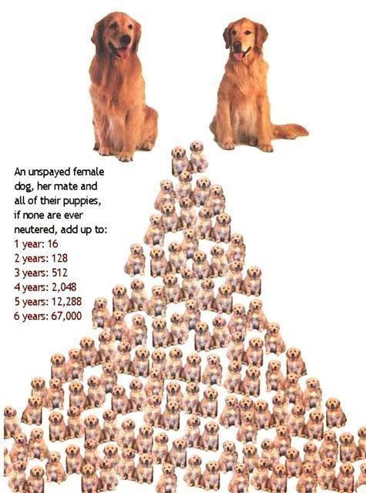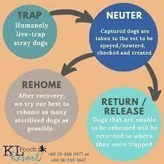

DESIGNING ALGORITHMS

As available resources are often limited, making informed decisions about where to allocate them becomes essential. So, in the pursuit of optimizing TNR Campaigns, Resource Allocation plays a pivotal role.

It is within this context that the connection between TNR campaigns and the renowned 0/1 knapsack problem, a classic optimization problem, emerges.
In this problem, we are given a set of items, each with a weight and a value. We are
also given a capacity, which is the maximum weight that we can carry. The goal is to find a subset of items that maximizes the total value, while satisfying the capacity constraint.
By leveraging the principles of this optimization challenge, we can devise strategies for allocating resources efficiently, maximizing the impact of TNR campaigns and ultimately improving the lives of countless stray dogs.

We can map TNR campaigns to the 0/1 knapsack problem as follows:
- Items in knapsack- different colonies where TNR campaigns can be conducted
- Weight of each item- Overall cost of TNR campaign in that colony, ie. the stray dog population in the colony
- Value of each item- Social Impact value of conducting TNR campaign in the colony
- Capacity of knapsack- Total budget of the TNR Campaign, ie. the total dog population of the city

Impact Value Calculation Model For Colony Prioritisation-
I have designed a simplified yet comprehensive model that calculates the overall impact value of a colony based on various factors typically considered in TNR (Trap- Neuter-Return) campaigns:

- Population Density: Assigned a score to each colony based on its population density. A higher population density indicates a greater potential impact on population growth and community interactions. Assigned a scale from 0 to 55, with 55 indicating the highest population density.
- Public Interactions :Prioritized areas with higher public interactions, ie. resident population as higher public interactions signals more public well- being. Assigned a scale from 0 to 3, with 35 indicating the highest level of public interaction.
- Community Input: Incorporate community input by assigning a score based on the severity and frequency of reported issues, such as nuisance behavior, public health concerns, or risks to vulnerable populations. Assigned a scale from 0 to 10, with 10 indicating the highest level of concern.
•
Pseudocode- function TNRResourceAllocation(colonies, totalResources):
{
// Create arrays to store the characteristics and impact values of colonies populationDensity = [] publicInteraction = [] communityInput = [] impactValue = []

// Calculate and normalize the characteristics of each colony for each colony in colonies:
populationDensity.add(Normalize(colony.populationDensity)) publicInteraction.add(Normalize(colony.publicInteraction)) communityInput.add(Normalize(colony.communityInput))

// Calculate the impact value for each colony for i from 0 to length(colonies) - 1:
impactValue.add(CalculateImpactValue(populationDensity[i],
publicInteraction[i], communityInput[i]))

// Create a 2D array to store the dynamic programming table dpTable = new 2D array[length(colonies) + 1][totalResources + 1]

// Initialize the base cases for i from 0 to length(colonies): dpTable[i][0] = 0
for j from 0 to totalResources: dpTable[0][j] = 0

// Perform the knapsack dynamic programming algorithm for i from 1 to length(colonies): for j from 1 to totalResources:
if populationDensity[i-1] <= j:
dpTable[i][j] = max(impactValue[i-1] + dpTable[i-1][j-populationDensity[i- 1]], dpTable[i-1][j]) else:
dpTable[i][j] = dpTable[i-1][j]

// Trace back the selected colonies selectedColonies = [] i = length(colonies) j = totalResources while i > 0 and j > 0:
if dpTable[i][j] != dpTable[i-1][j]: selectedColonies.add(colonies[i-1]) j = j - populationDensity[i-1] i = i - 1

return selectedColonies
}
IMPLEMENTATION DETAILS

Flowchart-

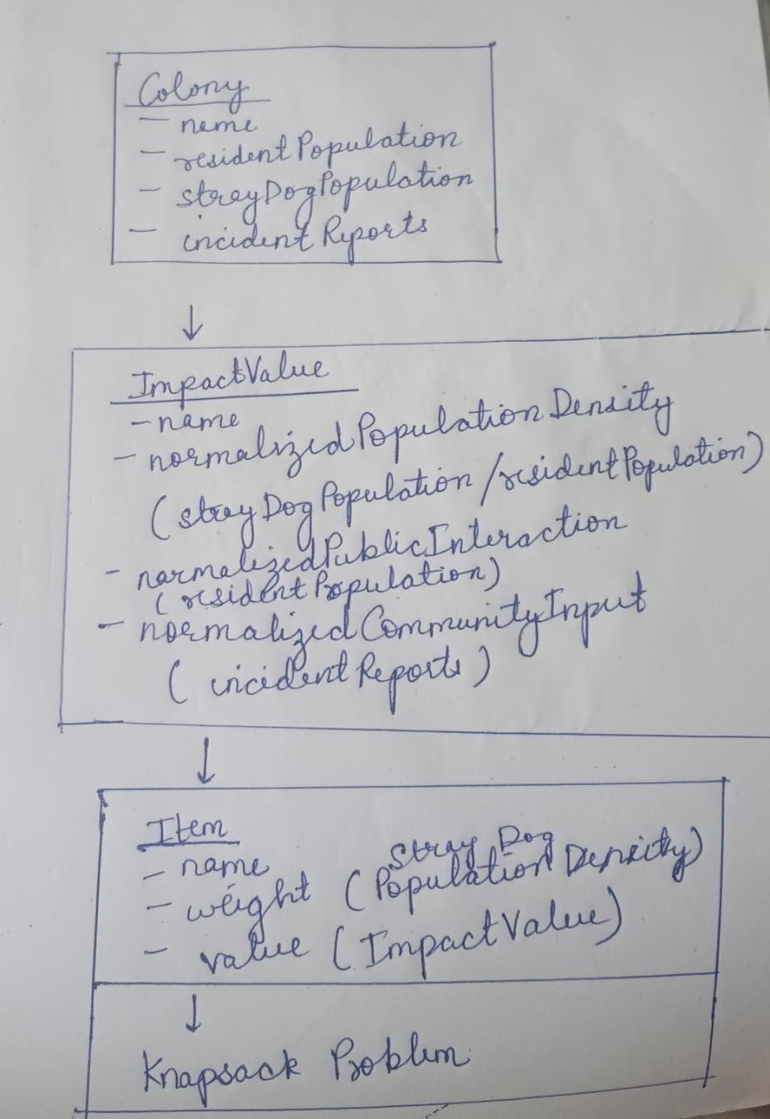

Code-

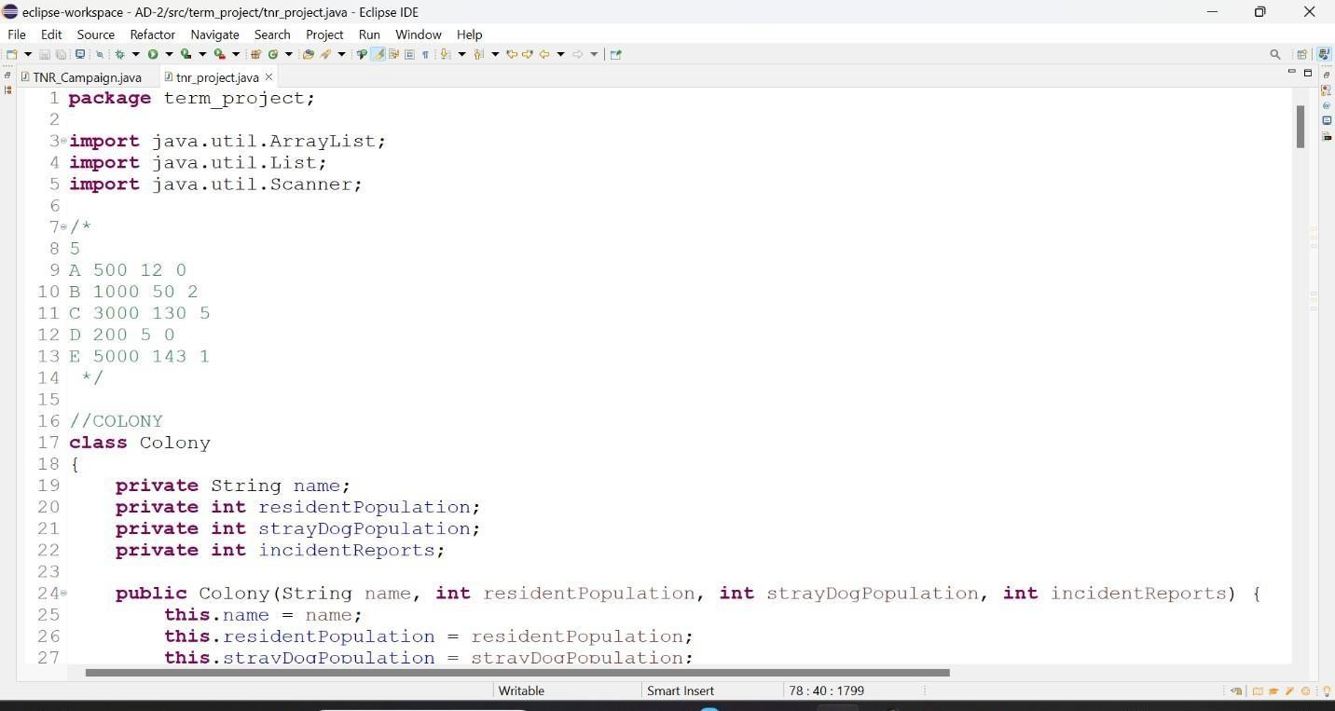
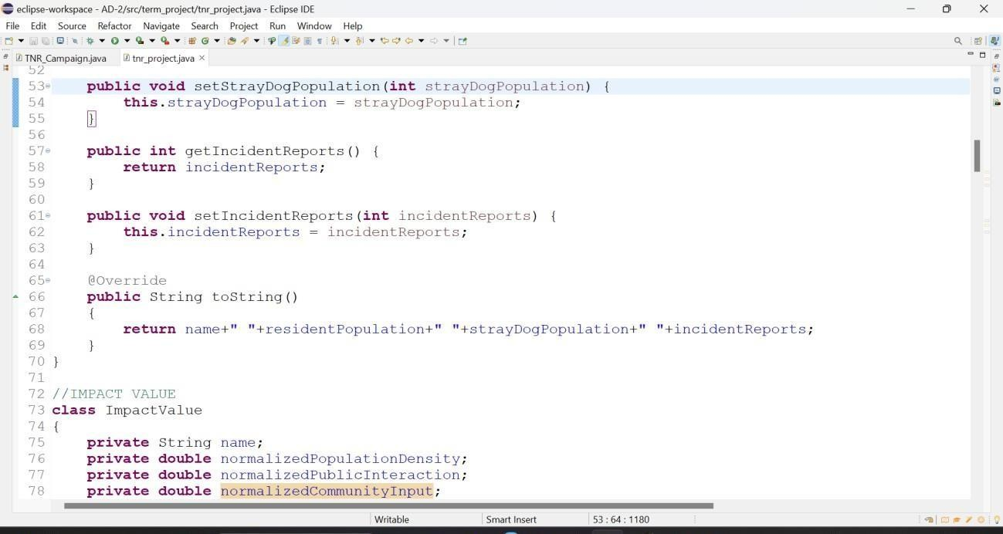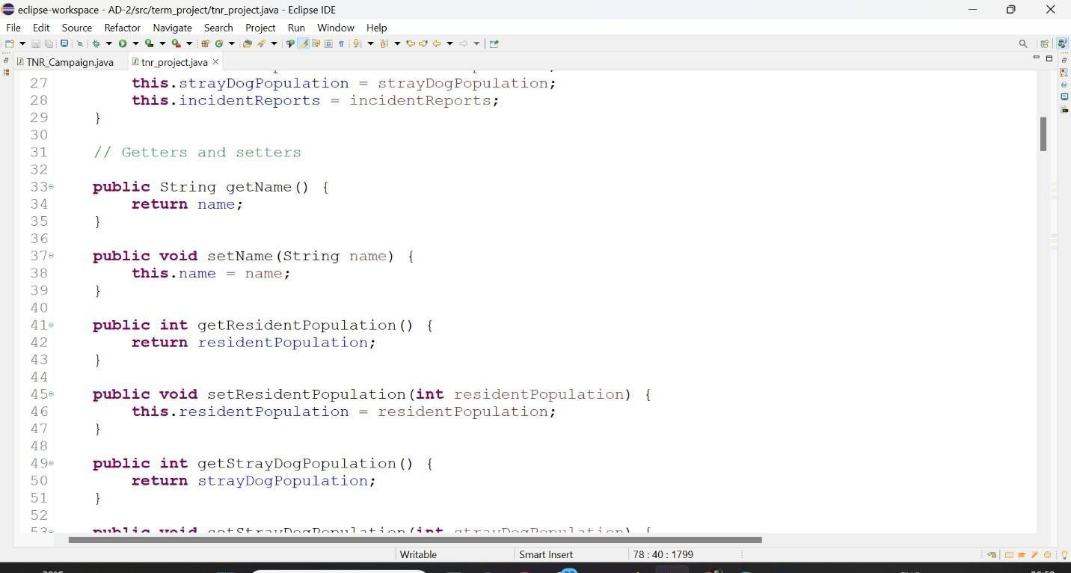
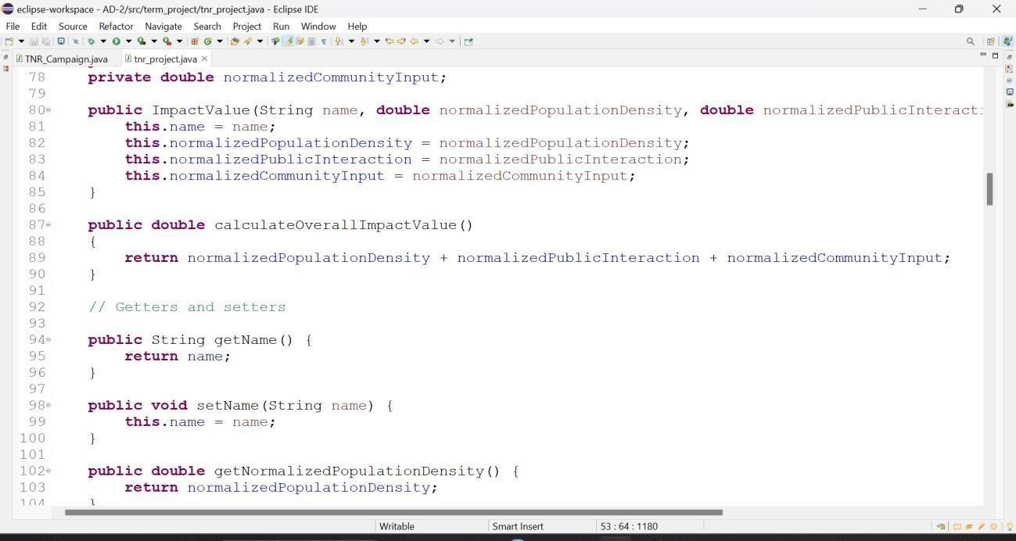

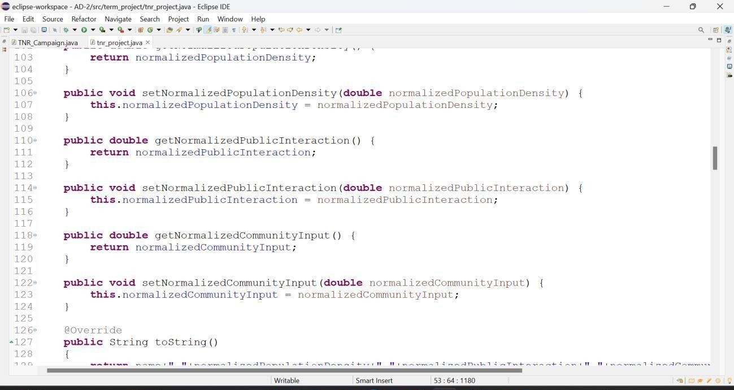
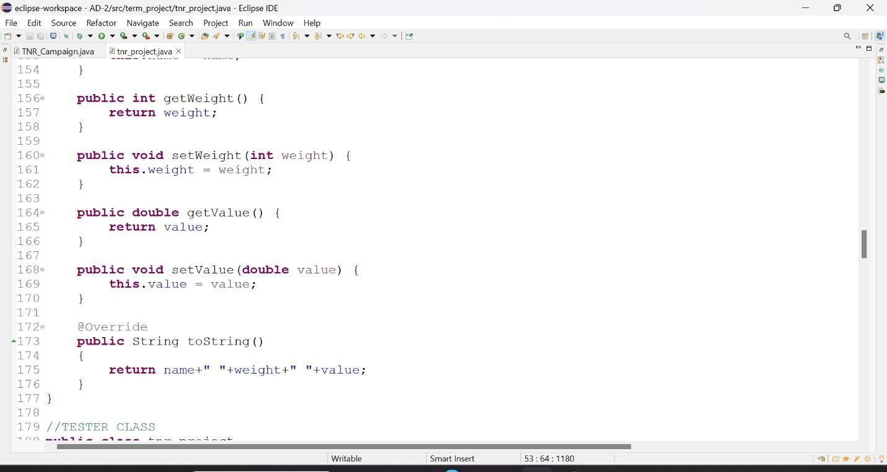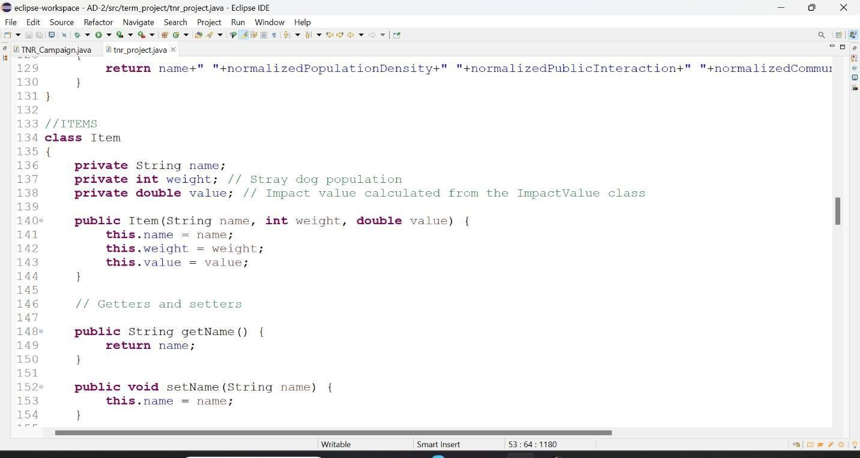
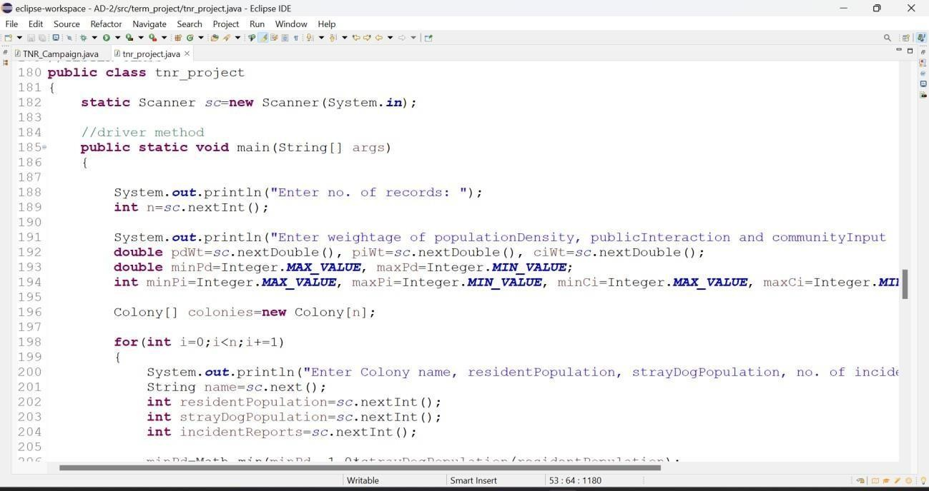

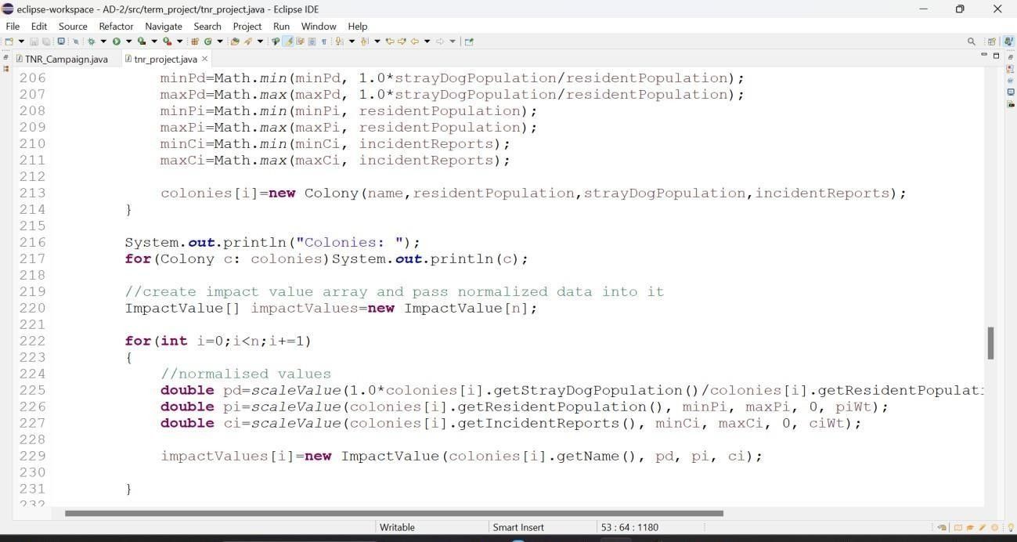
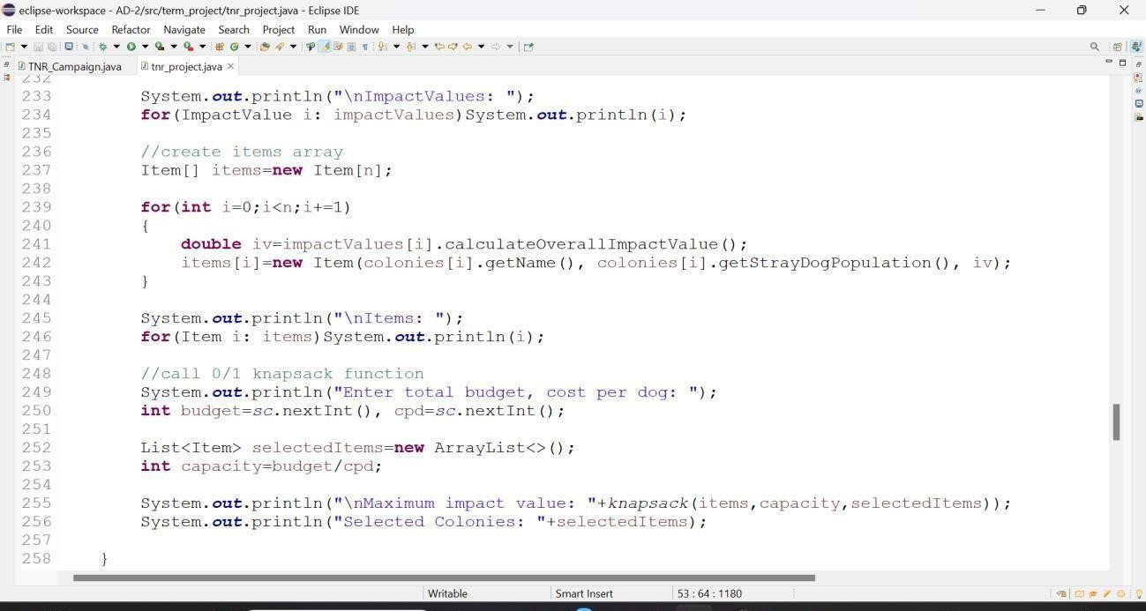

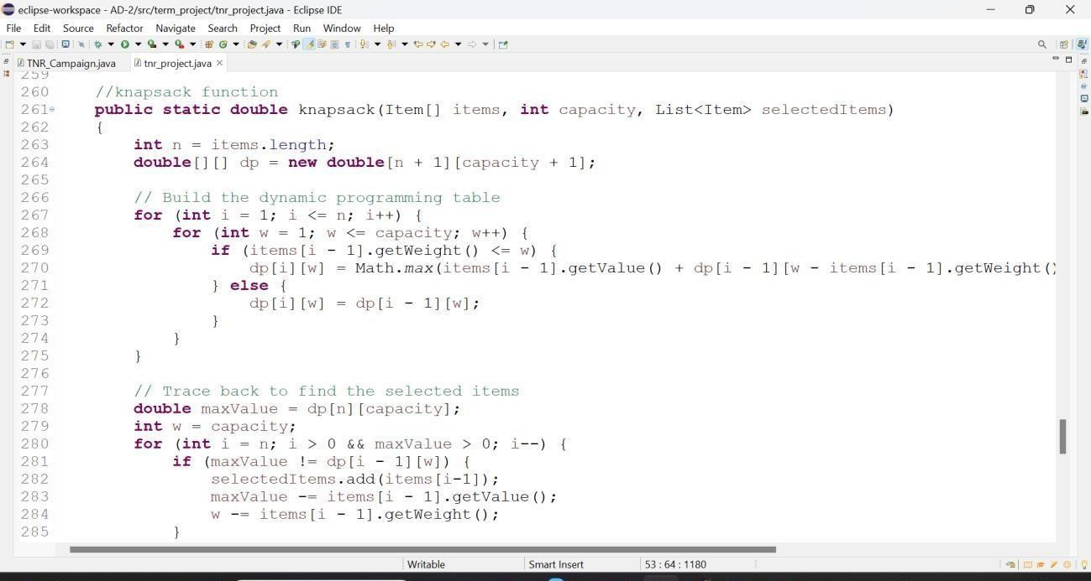
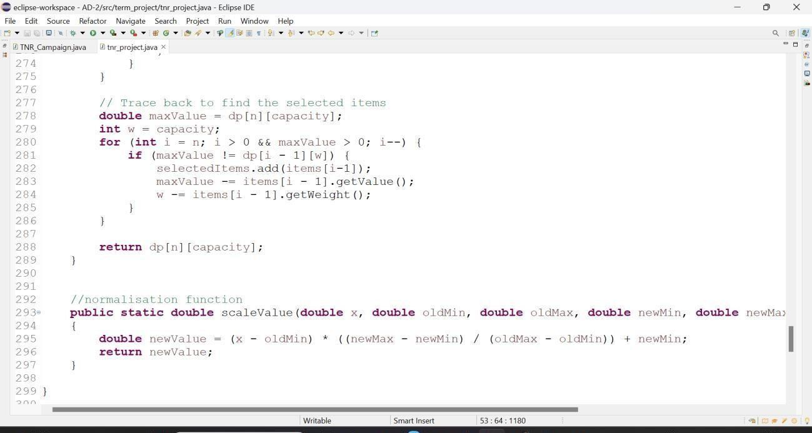

RESULTS AND DISCUSSIONS

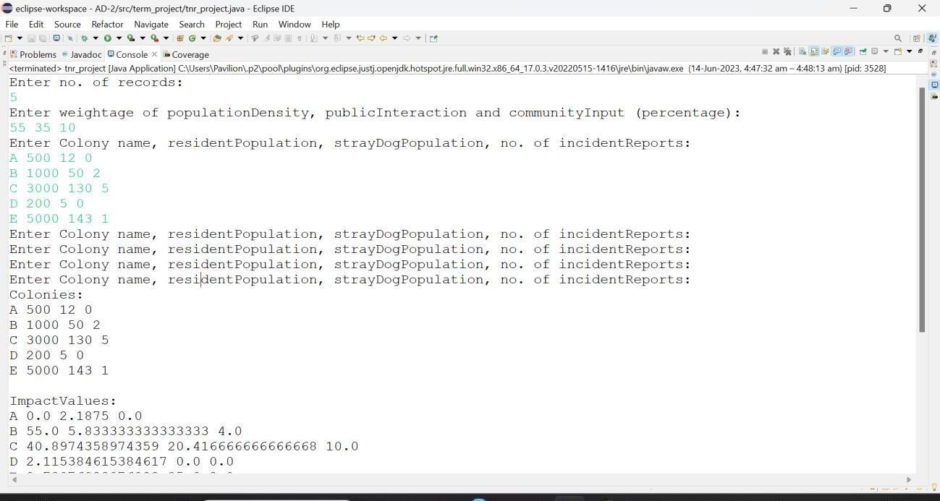
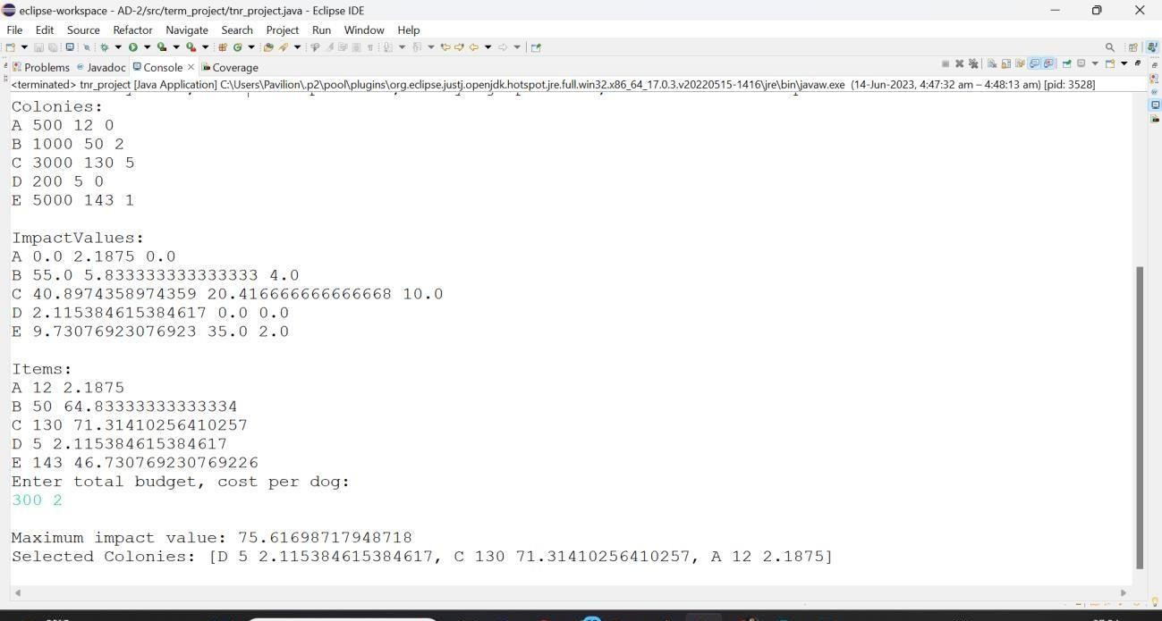

From the results, it is clear that colonies D, C and A must be prioritized first as they yield the maximum possible Social Impact Value within the limited budget.
So, by solving the 0/1 knapsack problem, we can find the optimal set of colonies where TNR campaigns should be conducted using the limited amount of budget. This will help us to allocate resources in a way that is most effective by utilizing the budget as much as possible while the Social Impact Value is maximized. LIMITATIONS

While resource allocation for TNR campaigns using the 0/1 knapsack problem can be a useful approach, it also has some limitations. Here are a few limitations to consider:
- Limited consideration of interdependencies: The 0/1 knapsack problem treats each colony as an independent item without considering potential interdependencies among colonies. However, in TNR campaigns, the presence of neighboring colonies and their dynamics can affect the effectiveness of resource allocation.
- Lack of real-time updates: The 0/1 knapsack problem assumes that all information about colonies and factors is known in advance. In practice, data about colonies and their characteristics may change over time, requiring a mechanism for real-time updates and dynamic adjustment of resource allocation.
- Complexity of factors: The 0/1 knapsack problem simplifies factors such as population density, public interaction, and community input into single values for each colony. However, these factors can be complex and multidimensional in reality, requiring a more nuanced approach for accurate resource allocation.

FUTURE ENHANCEMENTS
There are several potential future enhancements that can be considered to improve resource allocation for TNR campaigns using the 0/1 knapsack problem. Here are a few ideas:

- Dynamic resource allocation: Develop an algorithm that dynamically adjusts resource allocation based on changing factors such as available budget, seasonality, colony dynamics, and other relevant variables. This would allow for more adaptive and responsive resource allocation.

- Incorporate spatial considerations: Integrate geographic information systems (GIS) data and spatial analysis techniques to incorporate spatial factors such as proximity, connectivity, and geographic barriers into the resource allocation model. This would enable more effective allocation based on the spatial distribution of colonies.

- Consider population dynamics: Explore ways to incorporate population growth and dynamics of stray dogs into the resource allocation model. This could involve estimating future population changes based on historical data and implementing strategies to address colonies with high reproductive rates.

- Multi-objective optimization: Extend the resource allocation model to consider multiple objectives, such as maximizing impact value while minimizing costs or considering other factors like healthcare accessibility, vaccination coverage, or local regulations. This would allow for a more comprehensive and balanced approach to resource allocation.

- Machine learning and data analytics: Utilize machine learning and data analytics techniques to analyze large-scale data sets related to TNR campaigns, colony characteristics, and community feedback. This could help identify patterns, correlations, and predictive models to enhance resource allocation decisions.

- Real-time data integration: Implement mechanisms to collect and integrate real- time data from various sources, such as reported incidents, citizen feedback, or demographic changes. This would enable dynamic updates and adjustments to the resource allocation strategy based on the most up-to-date information.

These future enhancements aim to make resource allocation for TNR campaigns more dynamic, efficient, and adaptive to changing circumstances. By incorporating
advanced technologies and considering additional factors, the effectiveness and impact of TNR campaigns can be further improved.

REFERENCES
- Kleinberg, J., & Tardos, E. (2006). Algorithm design. Pearson Education India.
- Cormen, T. H., Leiserson, C. E., Rivest, R. L., & Stein, C. (2022). Introduction to algorithms. MIT press.
- PashudhanPraharee, STREET DOG ISSUE : SOLUTIONS & STRAY DOG’S LEGAL RIGHTS IN INDIA

- Integrating Trap-Neuter-Return Campaigns Into a Social Framework: Developing Long-Term Positive Behavior Change Toward Unowned Cats in Urban Areas, Jennifer L. McDonald,1,2,* Mark J. Farnworth,3 and Jane Clements1
- A Pilot Study to Develop an Assessment Tool for Dogs Undergoing Trap-Neuter- Release (TNR) in Italy. An Overview on the National Implementation of TNR Programmes
Greta Veronica Berteselli,1,2,* Cristina Rapagnà,1,3 Romolo Salini,1 Pietro Badagliacca,1 Fabio Bellucci,1,4 Filomena Iannino,1 and Paolo Dalla Villa1
- Stray Dogs and Public Health: Population Estimation in Punjab, India
Gurlal S. Gill,1,2 Balbir B. Singh,1,3,* Navneet K. Dhand,3 Rabinder S. Aulakh,1
Michael P. Ward,3 and Victoria J. Brookes3

